Task 1

# Enable and configure windows Defender;

Step 1) Open Window Security.

Step 2) Turn ON Virus and Threat protection.

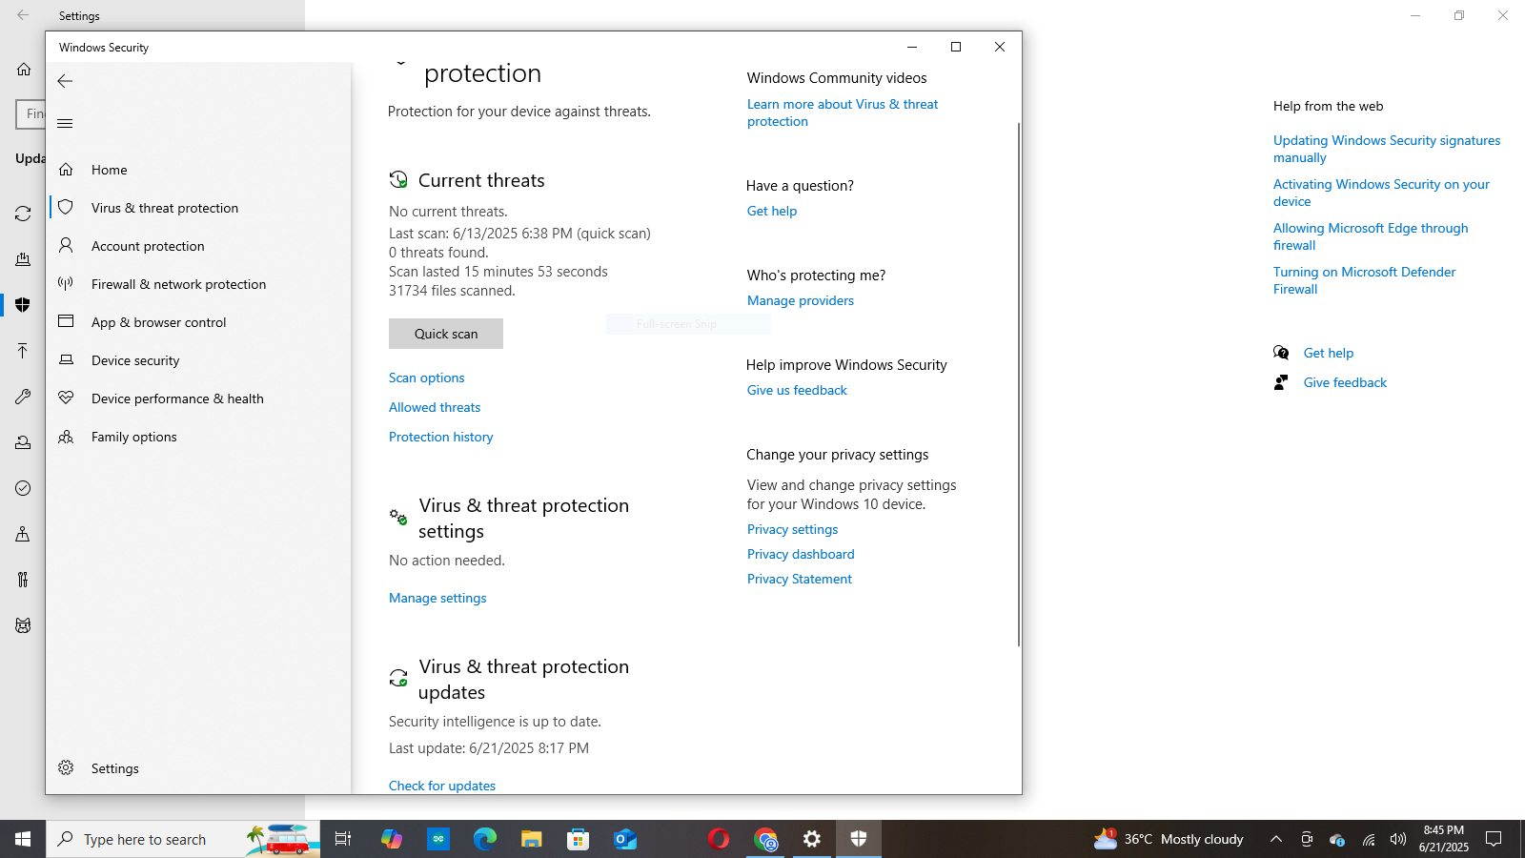

# Enable Windows Defender Firewall;

Step 1) Open Windows Security and search firewall.cpl.

Step 2) For both public and private networks turn ON Windows defender Firewall.

Step 3) Click ok to save

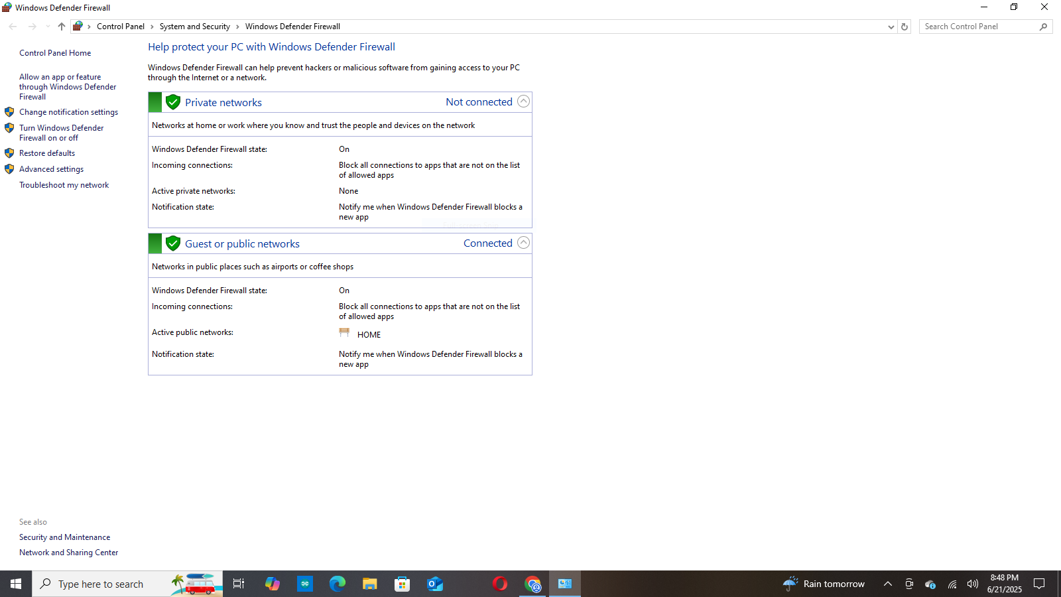

# Set rules to block or allow specific application;

1. Open windows security and search wf.msc.
2. Right- click on inbounded rules and select programs select new rules and then select .exe files of apps u want to block.
3. Then click on Inbounded rules follow same steps to allow specific apps

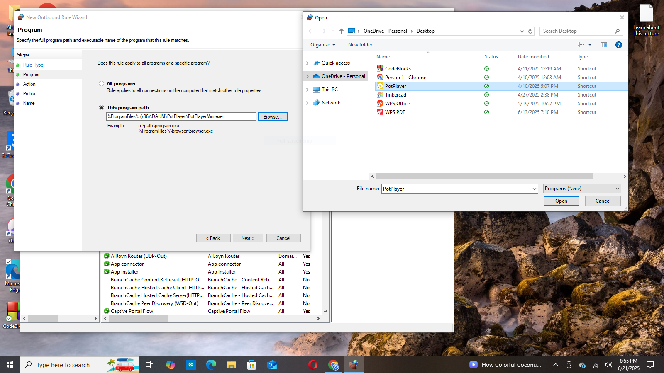

# Verify;

Go back to wf.msc to see new rules

